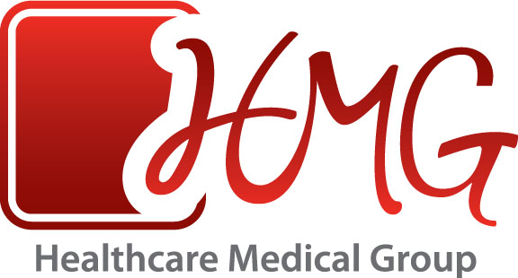

For more information, contact

Christina Ryan
870.530.3965
christina@hmg.md

News Release

Preventing Sudden Cardiac Arrest

More than 1,000 student athletes to receive free sports physicals.

Some physicians and communities say it can’t be done, and some say the costs outweigh the benefits. But in one town in Arkansas, the area’s largest physician group and most advanced medical center are doing it – sponsoring physicals for every single student athlete – and have been for three years running now.

Healthcare Medical Group (HMG), Northeast Arkansas’ largest physician group, in conjunction with St. Bernards Medical Center, recognized a community need to ensure the safety and health of local student athletes.

As part of the annual HMG Health and Fitness Expo, which attracts 15,000 visitors each April, the more than 175 HMG physicians donate their time and energy to offer sports physicals to each area school. Student athletes from six different school systems will receive the country’s most comprehensive physical. Every student entering the 9th through the 12th grade will be given a free EKG. If any abnormalities are detected, they will be given an on-site echocardiogram. This test can prevent sudden cardiac arrest, a tragic condition that claims the life of an American athlete every 3 days.
These heart-related screenings – along with eye, ear-nose-and-throat, orthopedic, height, weight, blood pressure, cholesterol, sickle cell, glucose and anemia screenings – help make sure that student athletes are healthy enough to safely participate in school sports. Junior high students will be given the same screenings, minus the EKG.
HMG Health & Fitness Expo is a free two day event focusing on the promotion of better health for Northeast Arkansas and Southeast Missouri. Scheduled for April 16th & 17th this year at the Arkansas State University Convocation Center, the Expo offers free health screenings for the entire community, physician panel discussions, healthy cooking demonstrations, and a kid’s health zone. It is the largest and most comprehensive physician-led event in the country.

